A Project

Report On

Tourism Guide System

BY

NITHY APTIY A.V

BSC(CS)

Batch: 2020 – 5351

C enter : CHENNA I

Under the Guidance of,

J ayant V.

T echnical T rainer

EduBr i dge

(School of coding)



Introduction:

Our project explain about the Pets selling WebSite name Puppies Sale .This project mainly explains the various a ctions related to shop online. Y ou can

Search various pets in this wed site we have all type of pets . Our Project Include

I have developed this Application in J ava, J SP, Servlets,

and MySQ.its a web-based project so I have used HTML,CSS,JavaScript



The main feature of the project is to sell pets easier. Y ou can

Access this website from any where and everywhere.

In **login Page** and user can submit their details.

In **pets details** we shows that we have vairety of pets.

**Admin Page** it is totally for Our purpose to know the person who registered for purchase pets.

**Software Requirements:**

**Front end**: Java/J2EE technologies (Servlet, JSP), HTML, CSS, J avaScri pt.

**Back end**: MySQL workbench 5.26CE.

**Mi ddl ewar e/Ser ver** : Apache Tomcat v8.0.

I**DE**: Eclipse IDE for Java EE

Dev el opers

**Br owser** : Best result on Google Chrome

Operating System: Window 10.

* image4Login Page
* RegisterPage
* Pets Details
* AdminPage

:



**Data Dictionary:**

**Create Database test510;**

* I Have used table members for login page and register page
* I have used table register for add user and view user.
* C R E A T E T A B LE members :

id int(10) unsigned N O T N U L L auto_increment,first_name varchar(45) N O T N U LL,

last_name varchar(45) N O T N U LL,email varchar(45) N O T N U LL, aadhar_num int(15) not null,address varchar(45) not null,uname varchar(45) N OT N U LL, pass varchar(45) N O T N U LL,confirmpass varchar(45) not null,regdate date N O T N U LL,

P R IM A R Y K EY (id) E N G IN E = InnoD B D E FA U LT C HA R S ET = latin1 ;

* C R E A T E T A B LE `register` :

`id` int(10) N OT N U LL A U T O_ IN C R E M E N T,`name` varchar(100)

N otNull,`password,varchar(100) N O T N U LL,`email` varchar(100) NOT N U LL,

`sex` varchar(100) N O T N U LL,`country` varchar(100) N O T N U LL,P R IM A R Y K EY (`id`)

E N G IN E =InnoD B D E F A U LT C HA R S E T = latin1 A U T O_ IN C R E M E N T=21 ;

Scr eenshots: -

Login Page:

REGISTER PAGE

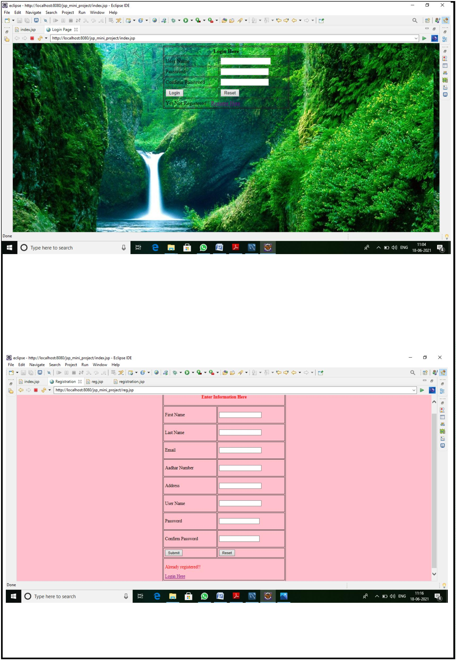

Registering with data:

Successful Registeration Data

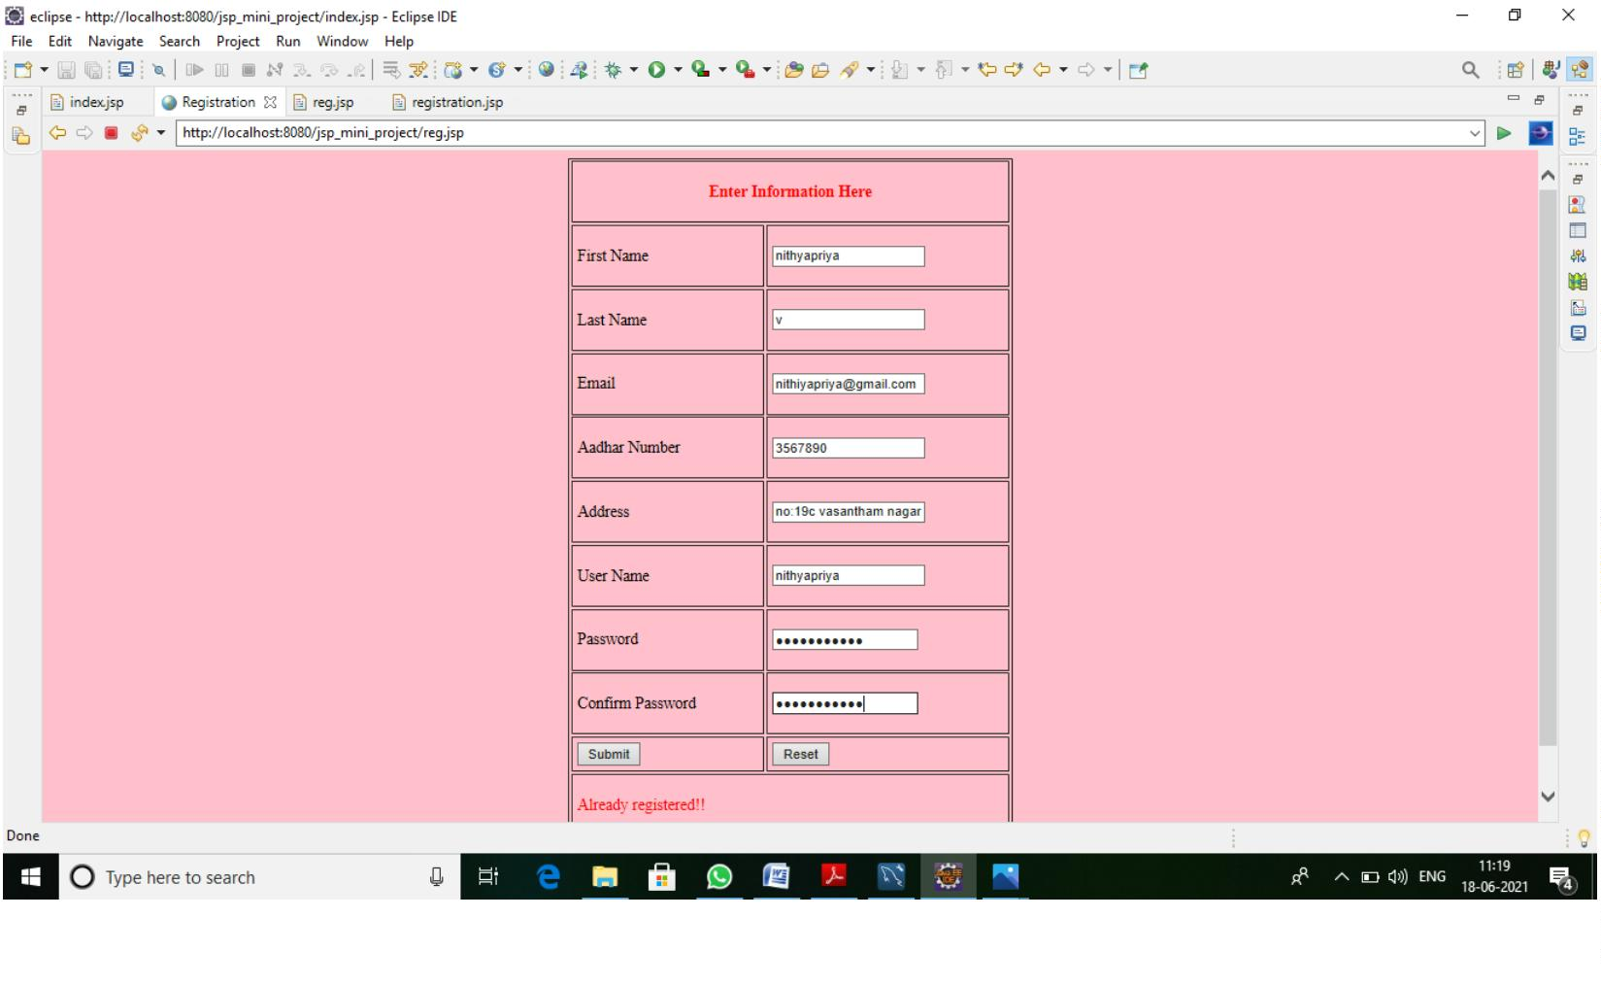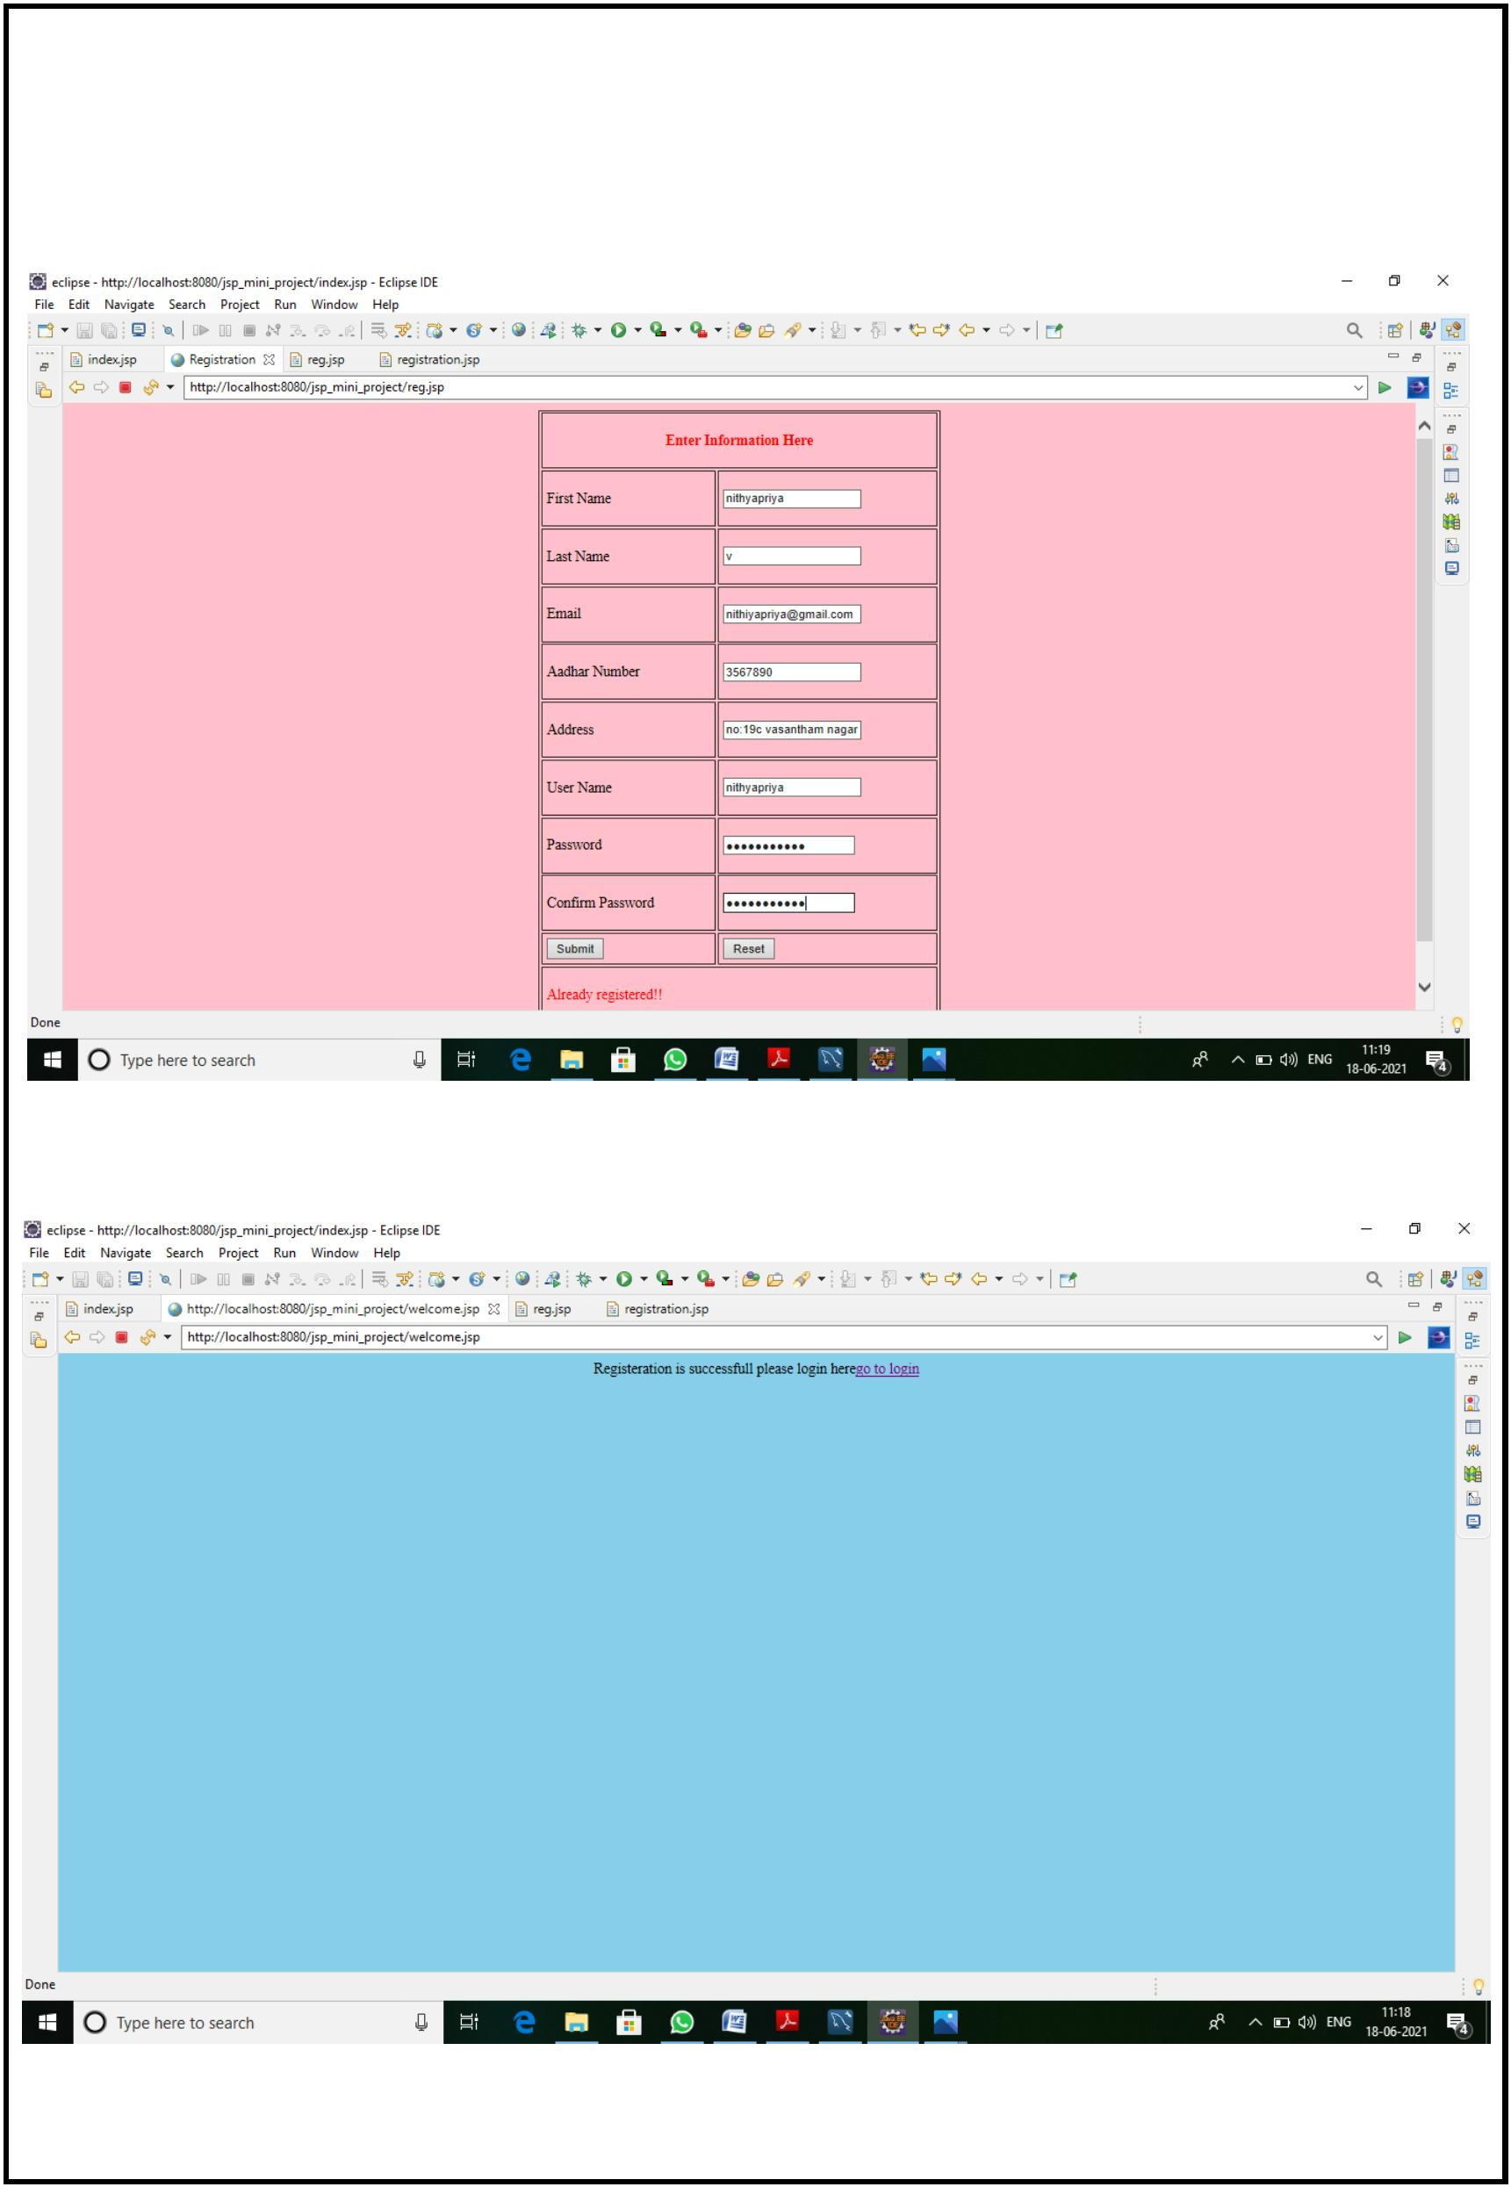

Login Page Error:

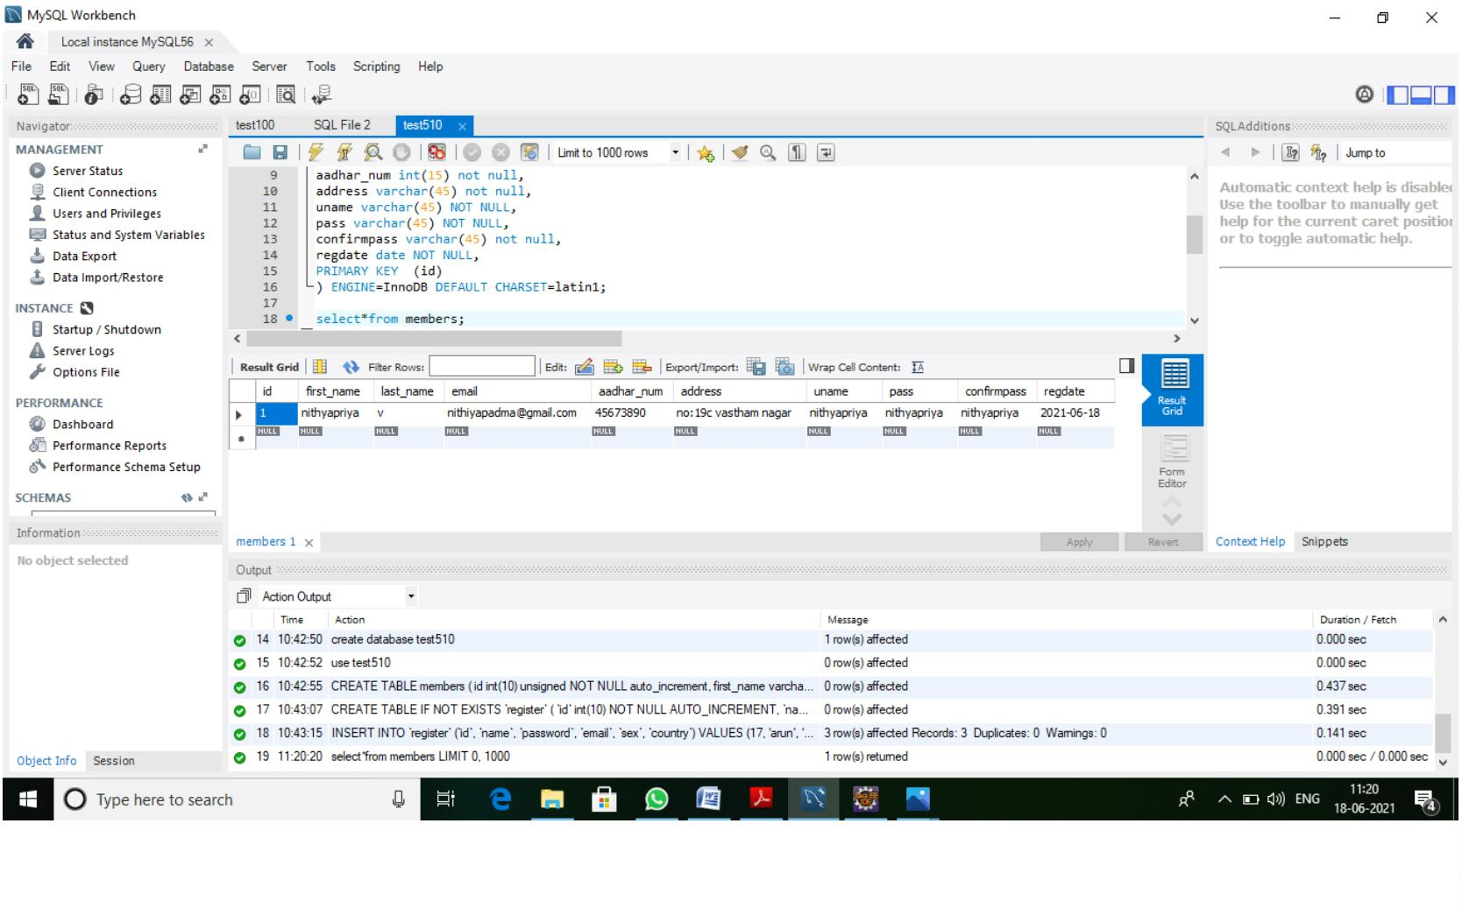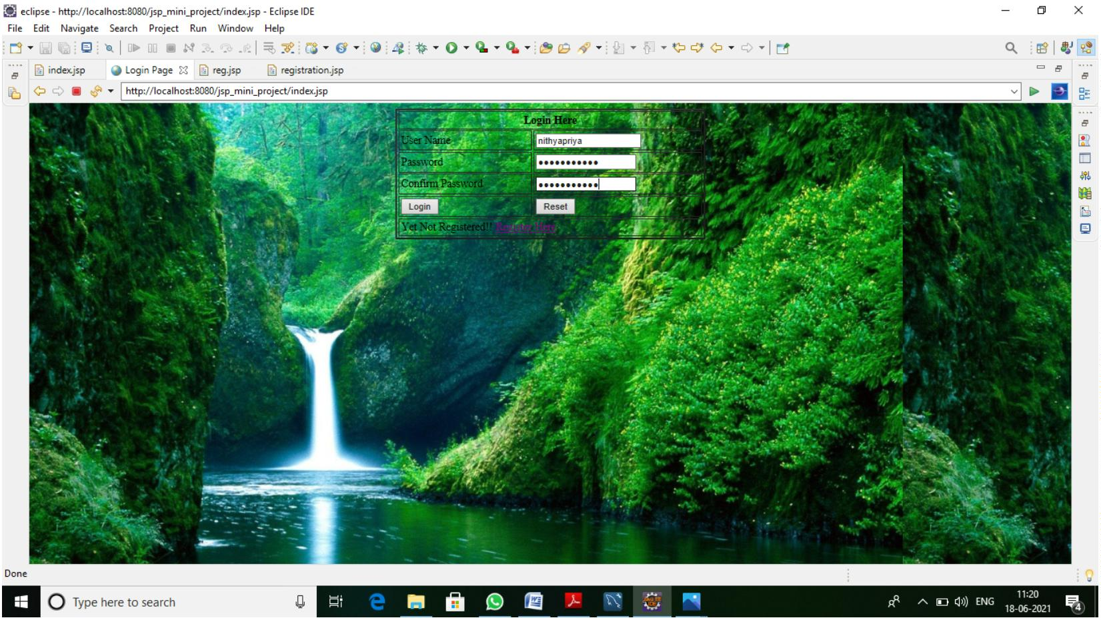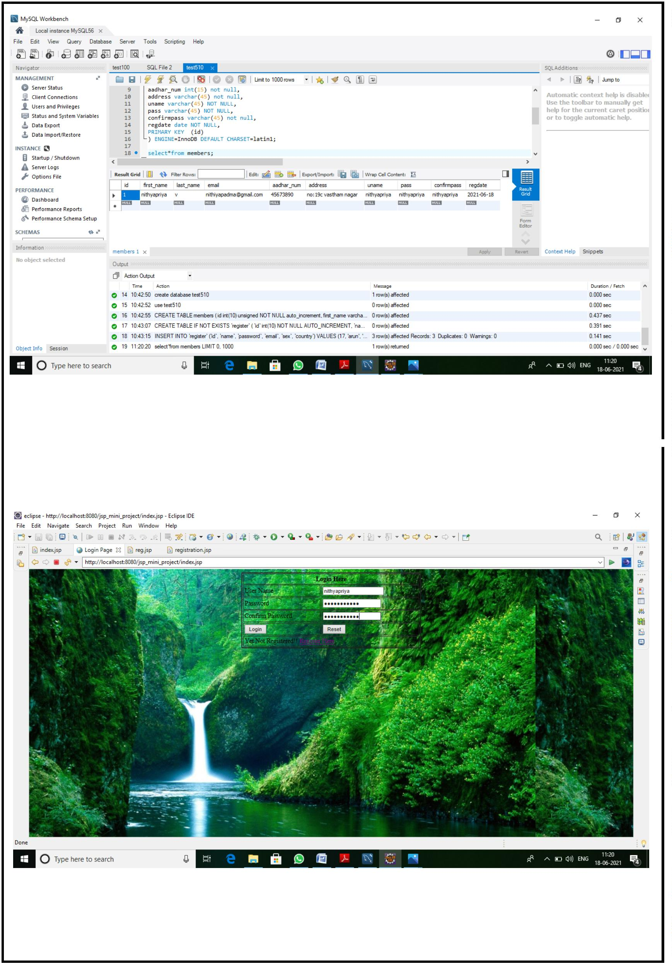

Selection page:

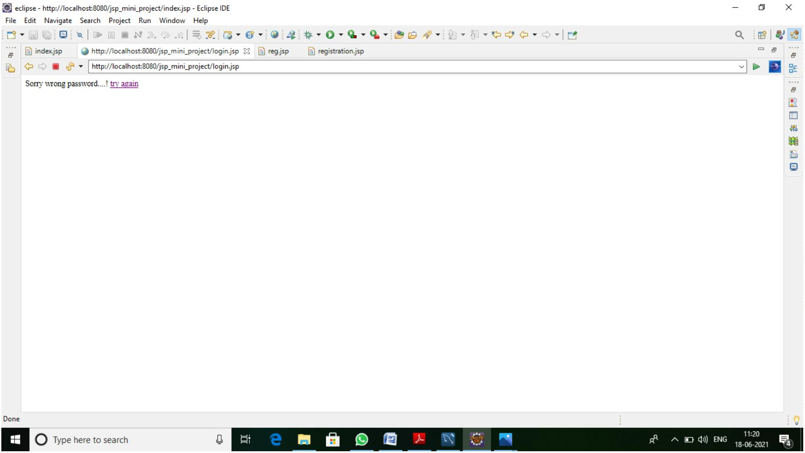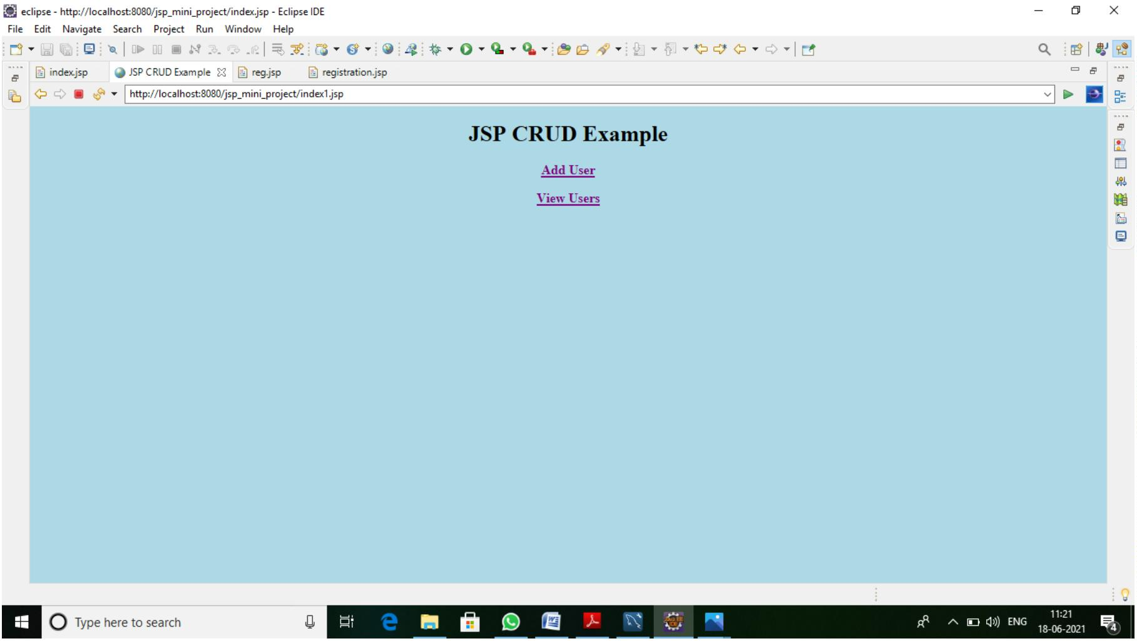

Add New User Page:

Error:

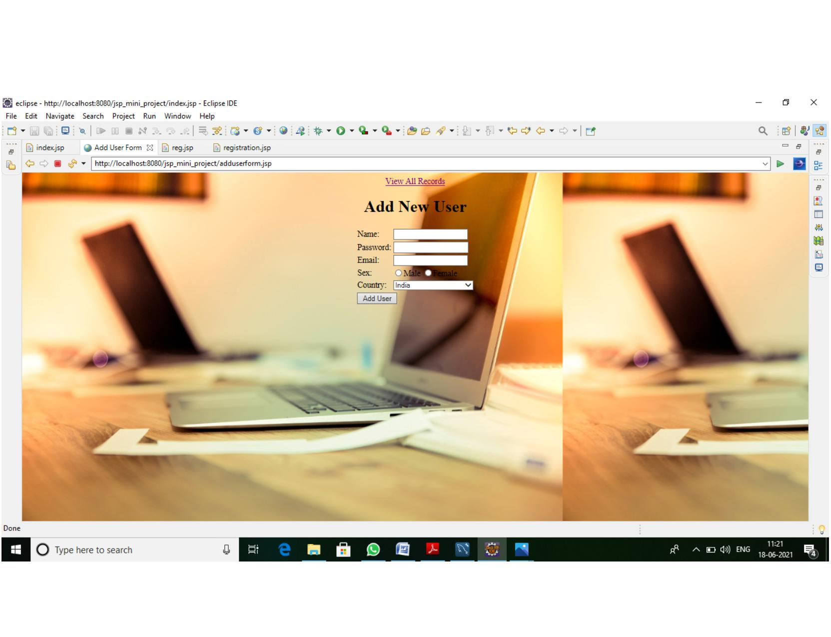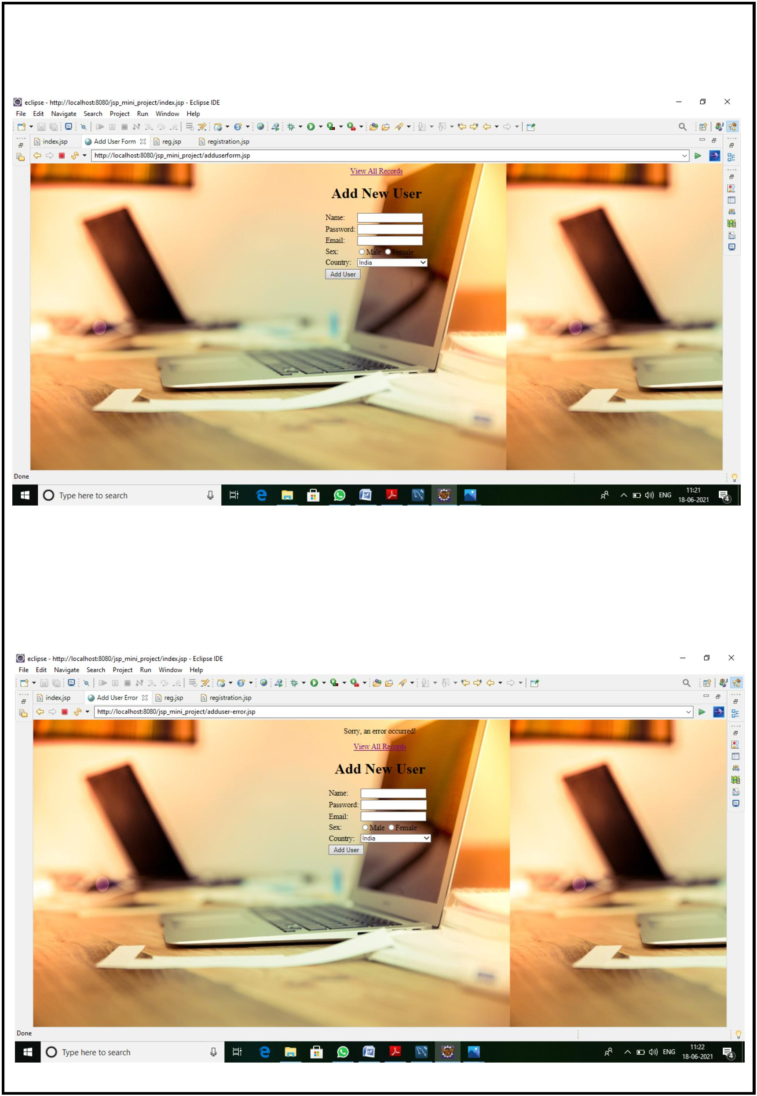

User List:

Sql Data List:

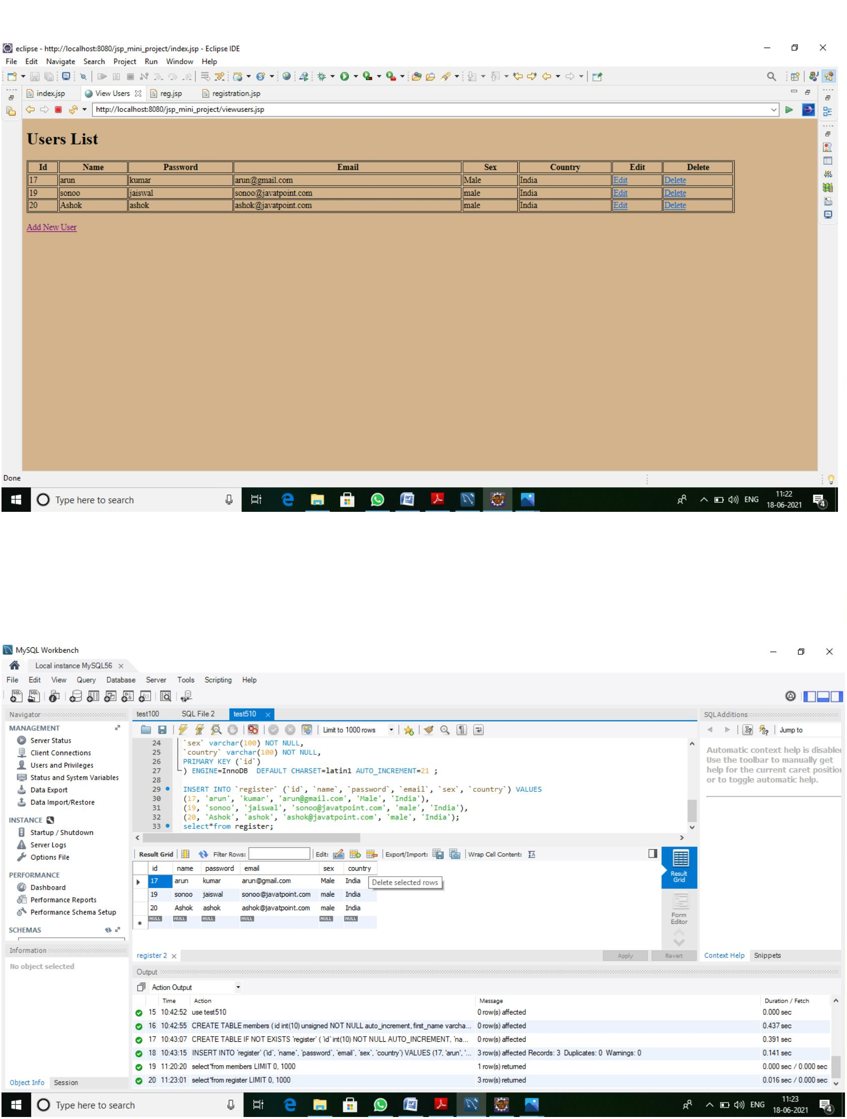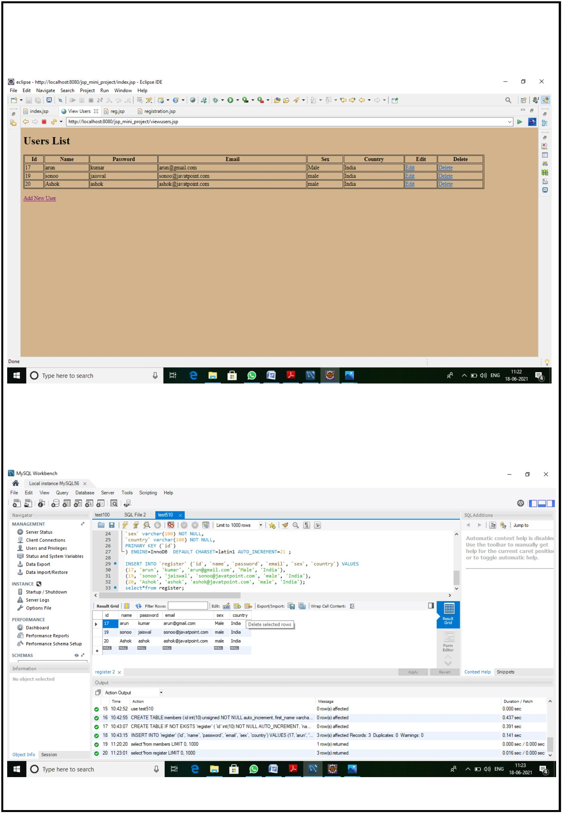

Add User Data:

Record Successfull Page:

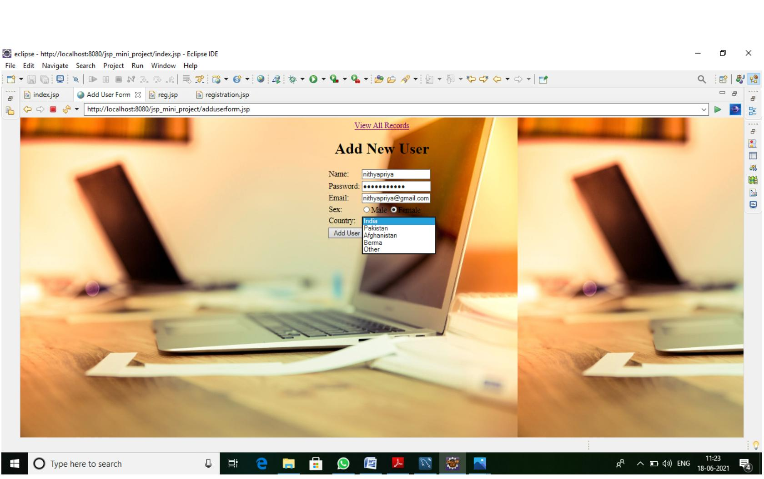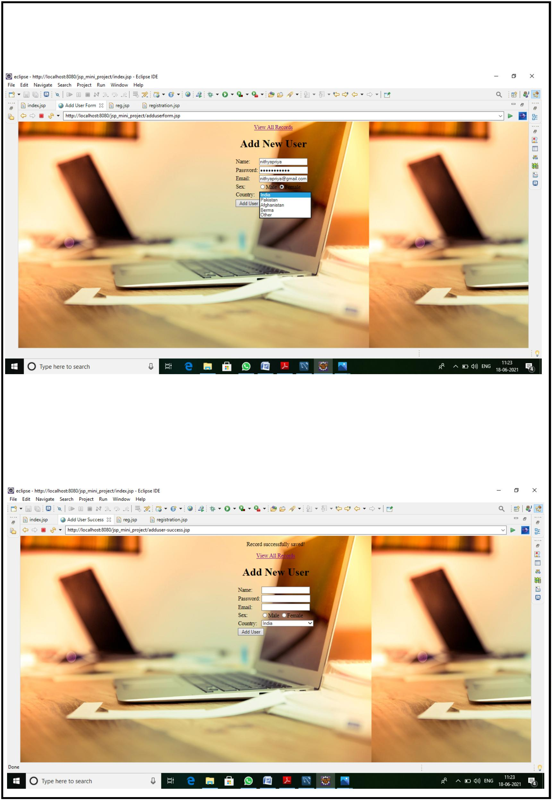

Add User List:

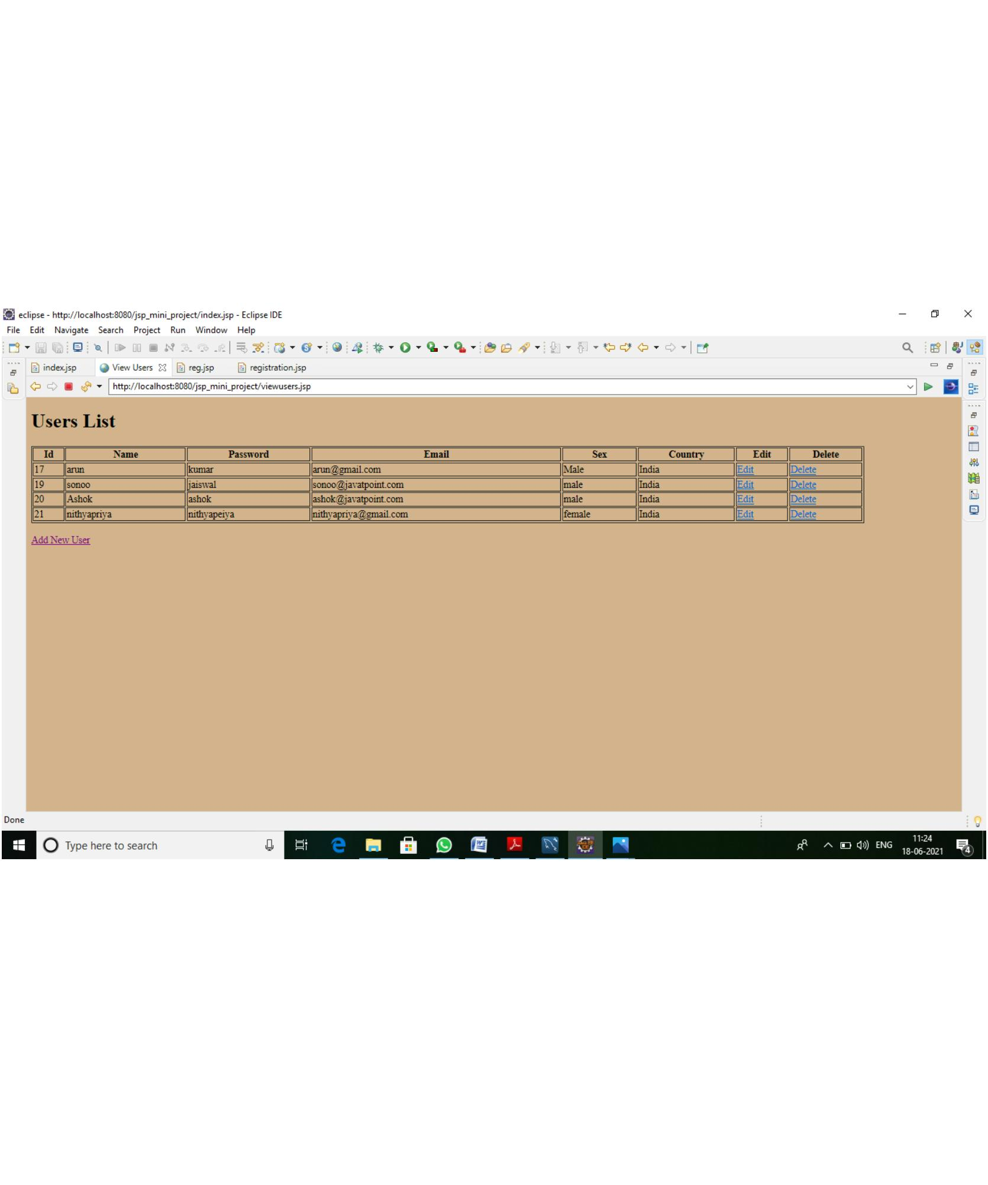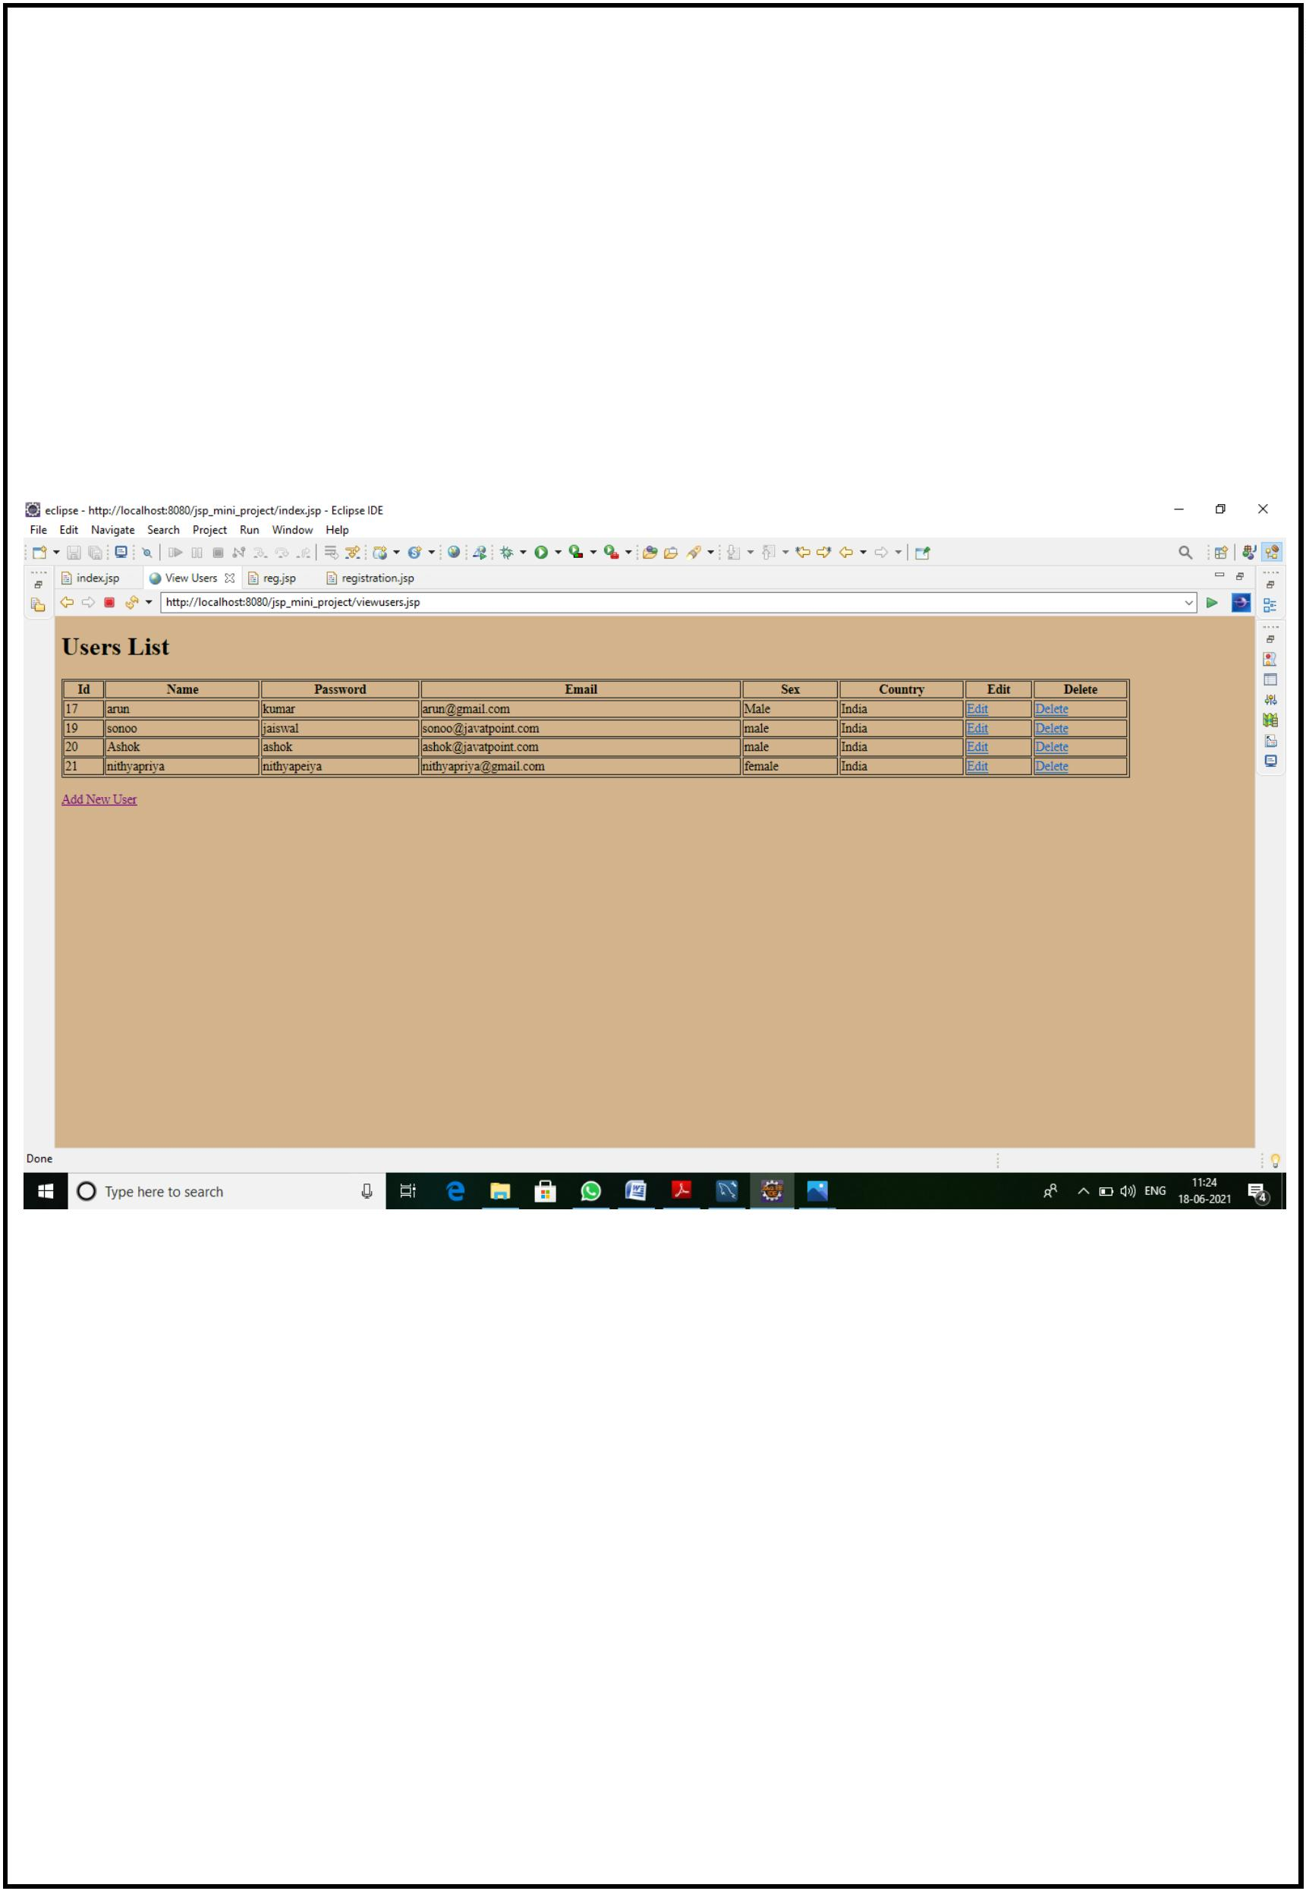

Sql Add Data List:

T hank you

